Bandit Level 5
DG Interns Hub | Week 1 | OverTheWire Bandit Writeup

Objective
Identify the human-readable file among several files.

Activity summary
Suggested learning command / approach: file inhere/*; cat <identified-file>. Use only on the authorized OverTheWire training environment.

Key learning
Identifying file types.

Evidence
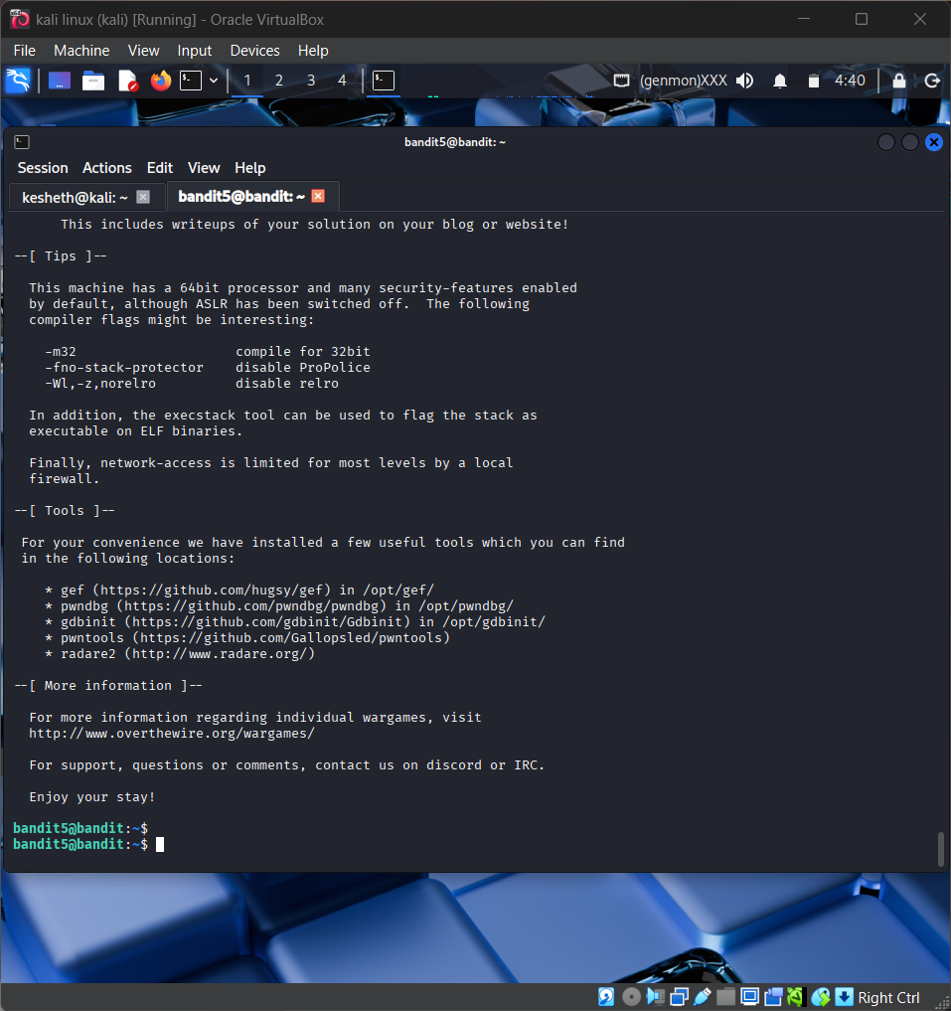
Screenshot: Bandit_Level_5.png
The screenshot is evidence of level activity/login; it may not show every solution step. No passwords are reproduced.

